**12-05-2023 ASSIGNMENT 2**

**Analytical Question covered:**

1. Identify the error in program

#include<iostream>

void main()

{

int i=0;

i=i+1;

cout<<i<<" ";

cout<<i;

}

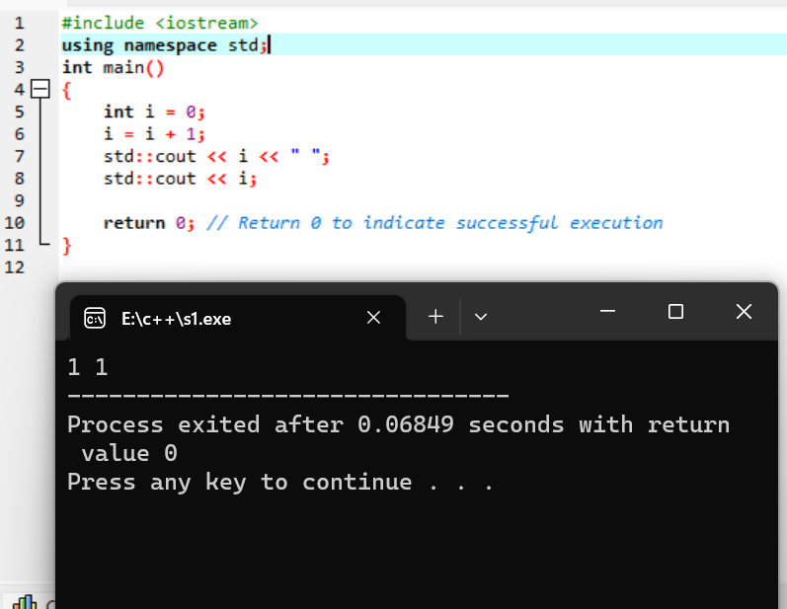

1. Identify the error

#include<iostream.h>

void main()

{

short i=2500, j=3000;

cout>>" i+j ">>=(i+j);

}

Answer:

#include<iostream>

Using namespace std;

int main()

{

short i=2500, j=3000;

cout<<" i+j "<<i+j;

return 0;

}

1. What will happen when you run following program.

/*

#include<iostream.h>

void main()

{

int i=10, j=5;

int modresult=0;

int divresult=0;

modresult=i%j;

cout<<modresult;

divresult=i/modresult;

cout<<divresult;

}

*/

#include<iostream>

using namespace std;

int main()

{

int i=10, j=5;

int modresult=0;

int divresult=0;

modresult=i%j;

cout<<modresult;

divresult=i/modresult;

cout<<divresult;

return 0;

}

1. **Write a c++ program**

What happens if the following program is executed in C and C++?

/*

#include <stdio.h>

int main(void)

{

const int j = 20;

int *ptr = &j;

printf("*ptr: %d\n", *ptr);

return 0;

}

*/

using namespace std;

#include<iostream>

int main(void)

{

int j = 20;

int *ptr = &j;

cout<<(*ptr);

return 0;

}

1. What happens if the following program is executed in C and C++?

/*

#include <stdio.h>

int main(void)

{

int new = 5;

printf("%d", new);

}

*/

C++

#include <iostream>

Using namespace std;

int main(void)

{

int myNewVar = 5;

:cout << myNewVar;

return 0;

}

C:

#include <stdio.h>

int main(void)

{

int myNewVar = 5;

printf(“myNewVar”);

return 0;

}

1. Write c++ program for finding Square root of number.

#include<iostream>

#include<math.h>

using namespace std;

int main()

{

float sq,n;

cout<<"Enter any positive number :: ";

cin>>n;

sq=sqrt(n);

cout<<"\nSquare root of Entered Number [ "<<n<<" ] is :: "<<sq<<"\n";

return 0;

}

1. A person wants to find his birthday day, but he has known no of days present only.

Find the no of days, no of years and no of weeks present for his birthday.

#include <iostream>

int main() {

int totalDays;

int years, weeks, days;

cout << "Enter the total number of days: ";

cin >> totalDays;

years = totalDays / 365;

totalDays %= 365;

weeks = totalDays / 7;

days = totalDays % 7;

cout << "Years: " << years << endl;

cout << "Weeks: " << weeks << endl;

cout << "Days: " << days << endl;

return 0;

}

1. A person wants to invest amount in financial institution and he wants find the compounded interest he will get, if no of year 385000, roi is 13.89 and time period is 4.

Write the code for above scenario.

#include<iostream>

#include<math.h>

using namespace std;

int main()

{

float p,r,t,ci;

cout<<"Enter Principle (Amount) :: ";

cin>>p;

cout<<"\nEnter Rate of Interest :: ";

cin>>r;

cout<<"\nEnter Time Period :: ";

cin>>t;

ci = p*pow((1+r/100),t);

cout<<"\nThe Calculated Compound Interest is = "<<ci<<"\n";

return 0;

}

/* C++ Program to Calculate Compound Interest */

Enter Principle (Amount) :: 385000

Enter Rate of Interest :: 13.89

Enter Time Period :: 4

The Calculated Compound Interest is = 647744

Process returned

1. C++ Program to Check Character is Uppercase, Lowercase, Digit or Special

#include<iostream>

using namespace std;

int main()

{

char ch;

cout<<"Enter any character to check :: ";

cin>>ch;

if(ch>=65&&ch<=90)

{

cout<<"\n The Entered Character [ "<<ch<<" ] is an UPPERCASE character.\n";

}

else if(ch>=48&&ch<=57)

{

cout<<"\n The Entered Character [ "<<ch<<" ] is a DIGIT.\n";

}

else if(ch>=97&&ch<=122)

{

cout<<"\n The Entered Character [ "<<ch<<" ] is a LOWERCASE character.\n";

}

else

{

cout<<"\n The Entered Character [ "<<ch<<" ] is an SPECIAL character.\n";

}

return 0;

}

OUT PUT:

/* C++ Program to Check Character is Uppercase, Lowercase, Digit or Special */

Enter any character to check::M

The Entered Character [ M ] is an UPPERCASE character.

1. Write a program to display ascii value of character.

#include <iostream>

using namespace std;

int main()

{

char c;

cout << "Enter any Character :: ";

cin >> c;

cout << "\nThe ASCII Value of Character [ "<< c << " ] is :: " << int(c)<<"\n";

return 0;

}

Out Put:

Enter any Character :: C

The ASCII Value of Character [ C ] is :: 67